WASTE CONNECTIONS OF AUSTIN

**WASTE & RECYCLE**

**SERVICE GUIDE**

# Welcome

Thank you for choosing Waste Connections as your solid waste solution. Waste Connections is a solid waste company that connects customers with safety and service. The enclosed information will be a brief guide to answer any questions you may have regarding your service.

## Setting up for Safe Service

Residents of Kelly Lane WCID # 1 will need to contact Crossroad Utilities at 512-246-1400 to establish new service, change to service or disconnect service. Please call Waste Connections Customer Service at 512-282-3508 to report service issues, schedule bulk pick up, container replacements, etc.

|  |  |  |  |  |  |
| --- | --- | --- | --- | --- | --- |
| **Kelly Lane WCID # 1 Service Info** | | | | | |
| **Service** | **Frequency** | **Service Day** | **Cart Size** | **Start Date** | **Service Limit** |
| Trash | Weekly | Friday | 95 Gallon | 9/29/2023 | Cart contents + up to 6 30 gal bags /35 gal containers or bundles placed next to our can. |
| Recycle | Bi-Weekly | Friday | 95 Gallon | 10/6/2023 | Cart contents only |
| Bulk | On-Call | On-Call | N/A | 9/29/2023 | 4 bulk pick ups per year per home, 4 yds per bulk pick up must call to schedule in advance |
|  |  |  |  | | |
| **To schedule bulk pickup:**  Please contact Waste Connections Customer Service at (512) 282-3508. Bulk items that are placed out on collection day and not properly scheduled will not be serviced. | | | | | |

## Acceptable waste items.

Your service is for standard household waste. Please do not place any hazardous materials in your cart for collection (oil, paint, chemicals, tires, lead acid batteries, etc.) **ONLY HOUSEHOLD TRASH IS ALLOWED IN CONTAINERS**. In addition, the landfill will not accept T. V’s, monitors, ac units, or refrigerators. These items will NOT be collected and are illegal to put in landfills.

## Trash Guidelines

Your Solid Waste Collection service day will be every Friday. Trash cart should be out at the curb

no later than 7:00 am.

* One (1) 95-gallon trash cart provided by Waste Connections
* Place cart and up to six (6) bags, personal containers (no larger than 35 gal) or bundles at curbside
* Large or bulky items will be collected at curbside & must be scheduled as needed

by contacting Waste Connections 512-282-3508.

* Additional carts are available for an additional charge. Additional carts will be billed directly to the resident.

## Recycling Guidelines

Your Recycle collection service day will be every other Friday. Recycle cart should be out

at the curb by 7:00 a.m. A separate truck from the Solid Waste Collection truck will pick up

recycle materials.

* Curbside recycling collection is serviced every other week
* One (1) 95-gallon recycling cart provided by Waste Connections
* Rinse all food waste from recyclables.
* Place all recyclables in the cart. No sorting is required.
* Place recycle cart three (3) feet away from your trash cart and any other object.
* Additional carts are available, upon request for residents requiring

more than one, for an additional charge. Requests for additional will be billed directly to

the resident.

Acceptable and Unacceptable Recycle Items

**Recyclable Paper** – Magazines, junk mail, boxboard, holiday & greeting cards, phone books,

home office paper, paper bags, catalogs and newspapers. It is not necessary to remove inserts.

**These Papers CANNOT Be Recycled** – Pizza boxes or any cardboard with food residue,

disposable paper plates & cups, paper towels, facial or toilet paper, wrapping paper and

gift bags, milk and juice cartons.

**Recycling Corrugated Cardboard** – Cardboard should be flattened or cut into

2 feet by 2 feet sections to allow the cardboard to fit inside the recycle cart.

Corrugated cardboard that is placed outside the recycle cart will be considered trash

and thrown into the residential garbage truck as regular residential garbage for disposal.

[Corrugated cardboard is thick and has a wavy middle layer. Moving and mailing boxes are

usually made from corrugated cardboard.]

**These Cardboards CANNOT Be Recycled** – Pizza boxes or any cardboard with food

residue. Cardboard that is wet or soiled.

**Recyclable Plastics to Put in Your Recycle Carts** – Containers including varieties of the types designated as #1, #2, #3, #4, #5, and #7 which include all plastic drink jugs, shampoo, liquid soap and detergent bottles, clean frozen trays, margarine and yogurt tubs, plastic take out and produce containers, plastic disposable plates, cups and utensils. Drain completely, remove caps and rings and flatten, when possible, before placing in the recycle cart.

**DO NOT Put These Plastics in Your Recycle Carts** – Plastic bags and packaging, Styrofoam, toys, other plastic bottles such as motor oil, cooking oil and antifreeze containers.

**Recycling Metal** – Rinse the following containers and put them in your single stream recycling cart with all your other recyclables. Aluminum cans (i.e., soda cans), tin and steel cans (i.e., tuna cans & soup cans), empty aerosol cans, and metal lids from glass jars. Do not put inside any bag / paper or plastic.

**These Metal Items CANNOT Go into the Recycle Carts** – Aluminum foil, coat hangers, paint and solvent containers, and scrap metal.

**Recycling Glass** – Rinse your glass bottles and jars. Include green, amber, and clear bottles and jars in your recyclables. No need to remove labels. Metal lids from jars may also go in recycle cart separately.

**These Glass Items CANNOT Go into the Recycle Carts** – Broken glass, light bulbs, mirror, windowpanes, dishes and cups, ceramics, ornaments and decorations and other glass products. When to expect your service.

## What to do if there’s a service issue.

We always recommend reporting a missed pickup so that we can troubleshoot and resolve the problem. You will be serviced on your service day starting as early as 7 am and it can be anytime throughout the day up to 7 pm. Residents should contact Waste Connections Customer Service (512) 282-3508 the next business day to report any service issues.

## Holiday service schedule.

We operate on a normal pick-up schedule for most holidays. The holidays that we observe are listed below.

### THANKSGIVING DAY | CHRISTMAS DAY | NEW YEARS DAY

If a holiday falls on Saturday or Sunday, your service will NOT be affected. Otherwise, service will run one day late if your normal collection day is on or after one of the observed holidays listed above.

**Still have Questions?** If you have any additional questions or concerns that we didn’t cover, please contact Waste Connections customer service at (512) 282-3508 or Crossroad Utilities (512) 246-1400

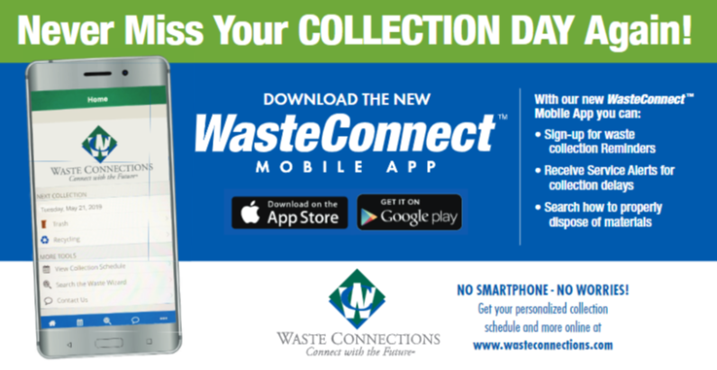

# Solid Waste Service Guide

### TRASH COLLECTION

* The green cart is for trash
* Residents may place out their 96 gal trash cart & up to 6 kitchen trash bags (13-30 gal each), 6 30 gal containers or 6 bundles of properly secured brush next to their container each service day
* Additional Containers should be no larger than 30 gallons & weighing more than 50 lbs including contents.
* Please put only normal household trash items inside your trash cart
* Please place your carts at the curb for collection before 7 am every **FRIDAY**
* To schedule a bulk pick up please contact customer service at (512) 282-3508.
* Bulk items placed at the curb that have not been scheduled in advance with customer service will not be serviced.
* Please do not overload your container (by weight or volume). Over loaded carts will NOT be serviced.
* Please DO NOT put medical waste, hazardous waste, explosives, flammable liquids pesticides, or animal carcass in the cart or on the curb for collection.
* Please DO NOT put any construction material, dirt, rock, or yard waste in your cart

### RECYCLE COLLECTION

* Recycle is serviced every **other FRIDAY**
* Please have carts curbside by 7 am on the service day
* Recycle service is cart contents only. All recyclables must be inside the cart.
* Recycle that is placed outside the cart is considered an unacceptable item & will be serviced as trash.

### Yard Waste (McKinney, Texas - Unique by Nature) &mdash; Nextdoor — Nextdoor